SUPPLEMENTARY

Table of Contents
Supplementary Methods 1. Prespecified safety topics of interest
Supplementary Figure 1: BE HEARD I and II and BE HEARD Extension study design
Supplementary Figure 2: Safety pooled data
Supplementary Figure 3: Missing data handling
Supplementary Figure 4: HiSCR50/75/90/100 over time in BKZ Total patients (mNRI [AE-LoE])
Supplementary Figure 5: Efficacy- and lesion-based outcomes over time in BKZ Total patients (MI [AE-LoE] and mNRI [AE-LoE])
Mean AN count over time (MI [AE-LoE])ª
Mean DT count over time (MI [AE-LoE])ª
Mean absolute change from baseline in DT count over time (MI [AE-LoE])ª
HSSQ skin pain response rates (mNRI [AE-LoE])^{b,c}
DLQI 0/1 response rates (mNRI [AE-LoE])^{b,d}
Supplementary Table 1. HiSCR50/75/90/100 to Week 96 in patients receiving BKZ Q2W/Q4W/Q4W (OC)

Supplementary Methods 1. Prespecified safety topics of interest
Prespecified safety topics of interest were infections (serious, opportunistic, including tuberculosis and fungal infections), inflammatory bowel disease (IBD), malignancies, major adverse cardiac events (MACE), liver function test changes and enzyme elevations, suicidal ideation and behavior (SIB), neutropenia, hypersensitivity reactions, and injection site reactions.
Predefined cardiovascular, gastrointestinal, neuropsychiatric, and hepatic events were reviewed and adjudicated by independent Cardiovascular, IBD, Neuropsychiatric, and Hepatology Adjudication Committees.

Supplementary Figure 1: BE HEARD I and II and BE HEARD Extension study design

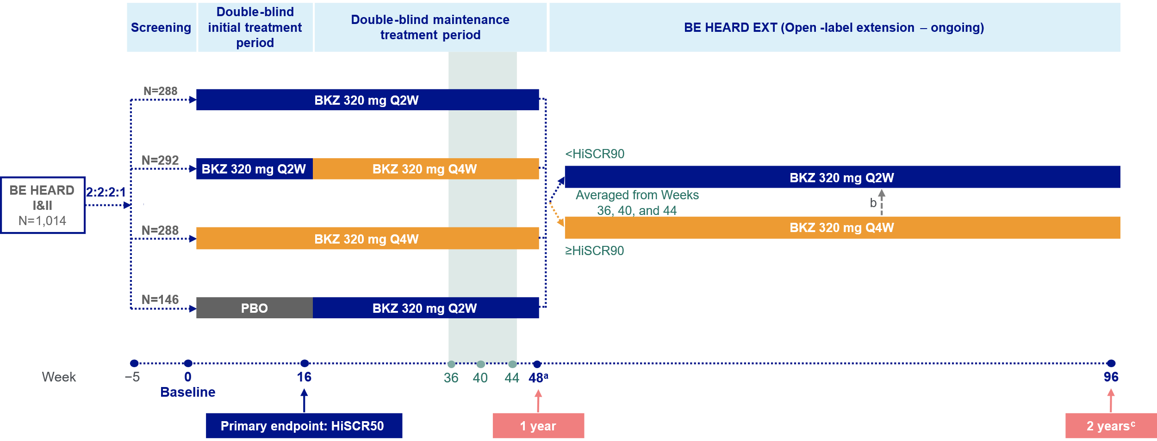
Hidradenitis suppurativa. [a] Patients who completed Week 48 of BE HEARD I and II could enroll in BE HEARD Extension and receive open-label BKZ Q2W or BKZ Q4W based on HiSCR90 responder status using the average lesion counts from Weeks 36, Week 40, and Week 44 of BE HEARD I and II; [b] In the first 48 weeks of the ongoing BE HEARD Extension, dose adjustment from BKZ Q4W to BKZ Q2W was permitted based on prespecified criteria for reduction in improvement from baseline in AN count; [c] Cumulative 2-year data (48 weeks in BE HEARD I and II and 48 weeks in BE HEARD Extension). AN: abscess and inflammatory nodule; BKZ: bimekizumab; HiSCR: hidradenitis suppurativa clinical response; HiSCR50/90: ≥50%/90% reduction from baseline in the total AN count with no increase from baseline in abscess or draining tunnel count; Q2W: every two weeks; Q4W: every four weeks.

Supplementary Figure 2: Safety pooled data
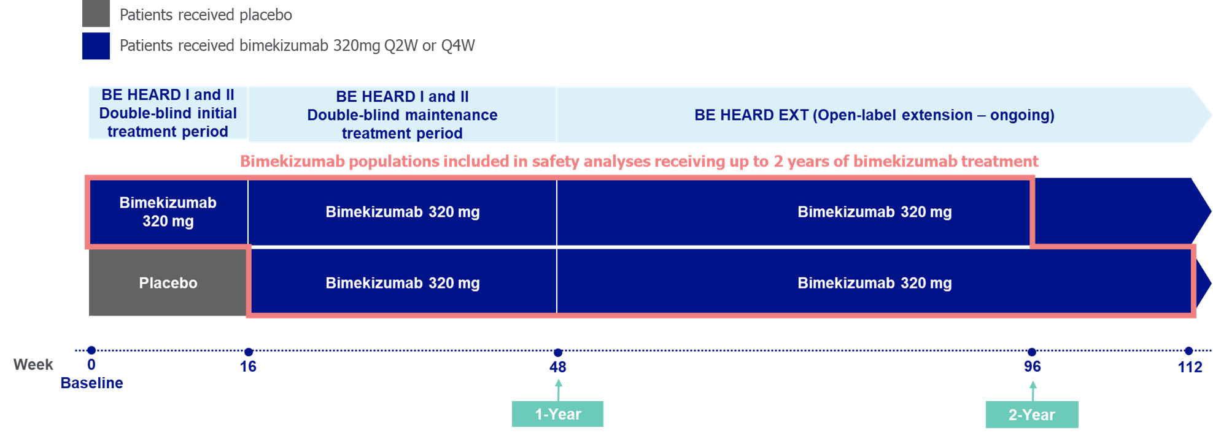
Hidradenitis suppurativa. Safety pool for patients who received up to 2 years of bimekizumab treatment. Q2W: every 2 weeks; Q4W: every 4 weeks.

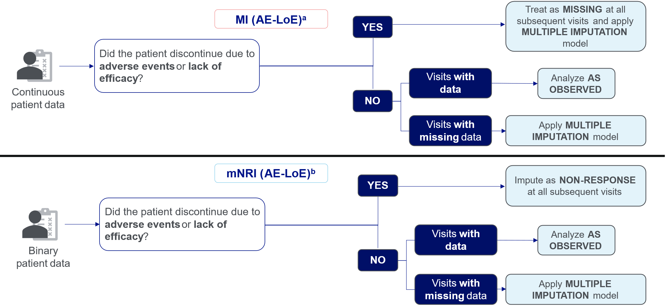
Supplementary Figure 3: Missing data handling
Hidradenitis suppurativa. For AE-LoE, discontinuation due to adverse event of lack of efficacy constitutes as an intercurrent event. [a] Intermittent missing data were imputed using multiple imputation with MCMC method followed by monotone regression for monotone missing data. Patients who experienced an intercurrent event were treated as missing following the intercurrent event and imputed using the multiple imputation method for missing data. [b] Intermittent missing data were imputed using multiple imputation with MCMC method followed by monotone regression for monotone missing data. Lesion counts were imputed and then dichotomized to obtain the response status. Patients who experienced an intercurrent event were treated as non-responders following the intercurrent event. Observed case reflects the patients who remained on treatment and missing data were not considered. AE-LoE: adverse event or lack of efficacy; MCMC: Markov Chain Monte Carlo; MI: multiple imputation; mNRI: modified non-responder imputation.

Supplementary Figure 4: HiSCR50/75/90/100 over time in BKZ Total patients (mNRI [AE-LoE])
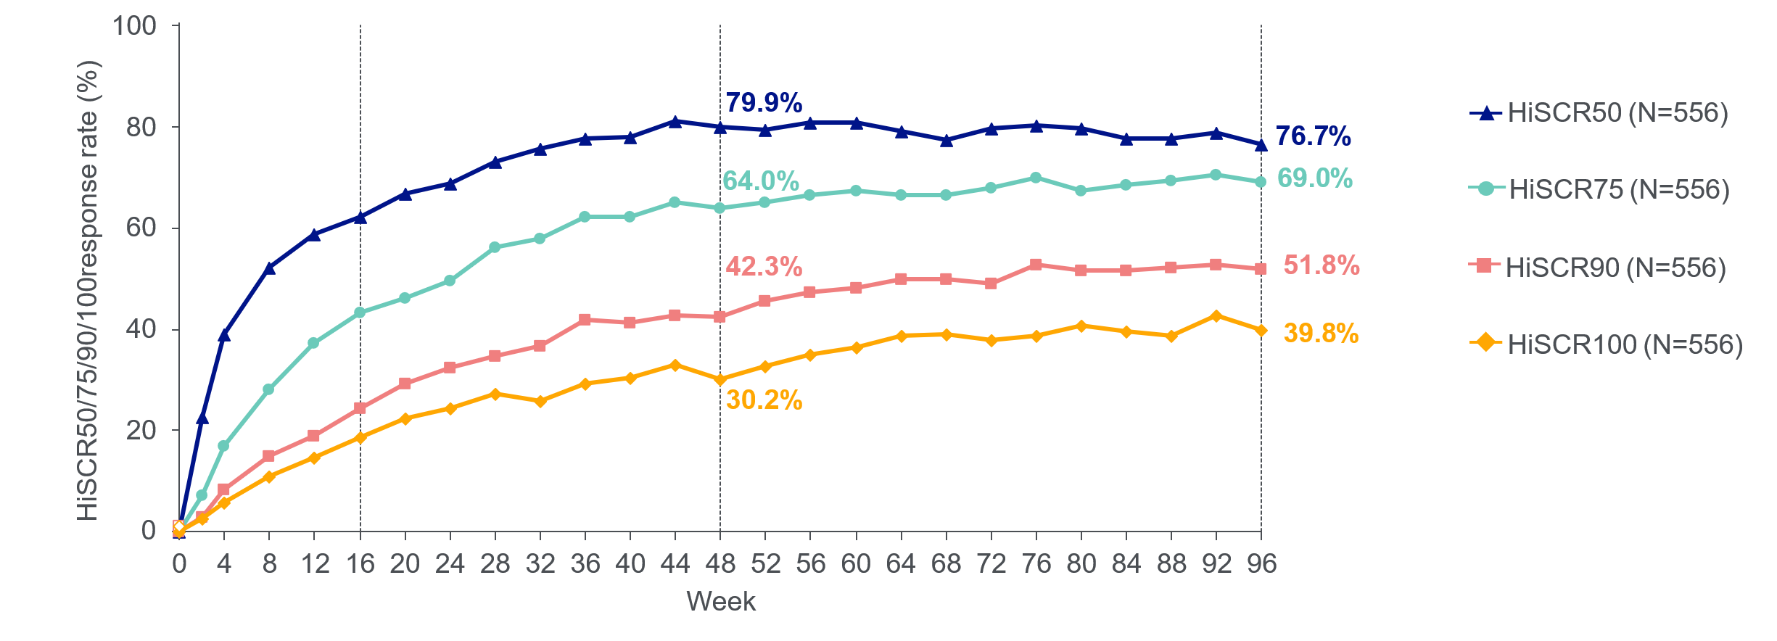
Hidradenitis suppurativa. OLE set: 657 BE HEARD I and II completers entered BE HEARD Extension at Week 48, of which 556 received BKZ from baseline (BKZ Total). Data for patients in BKZ Total are presented. BKZ Total comprised patients randomized to BKZ from baseline in BE HEARD I and II who entered BE HEARD Extension. Intermittent missing data were imputed using multiple imputation with MCMC method followed by monotone regression for monotone missing data. Lesion counts were imputed and then dichotomized to obtain the response status. For AE-LoE, discontinuation due to adverse event or lack of efficacy constituted as an intercurrent event. Patients who experienced an intercurrent event were treated as non-responders following the intercurrent event. AE-LoE: adverse event or lack of efficacy; BKZ: bimekizumab; HiSCR: hidradenitis suppurativa clinical response; HiSCR50/75/90/100: ≥50/75/90/100% reduction from baseline in the total abscess and inflammatory nodule count with no increase from baseline in abscess or draining tunnel count; MCMC: Markov Chain Monte Carlo; mNRI: multiple non-responder imputation; OLE: open-label extension.

Supplementary Figure 5: Efficacy and lesion based outcomes over time in BKZ Total patients (MI [AE-LoE] and mNRI [AE-LoE])

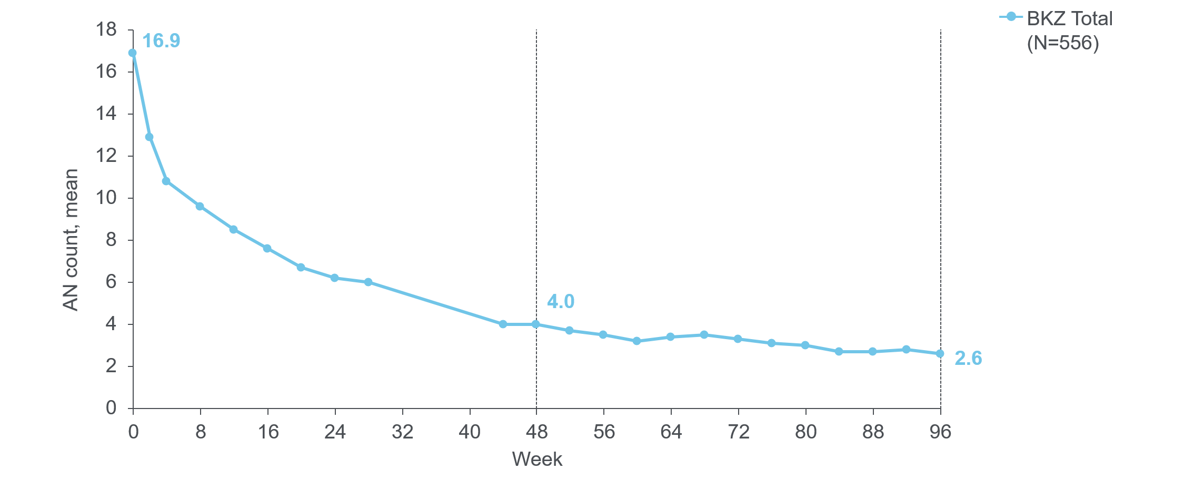
Mean AN count over time (MI [AE-LoE])ª

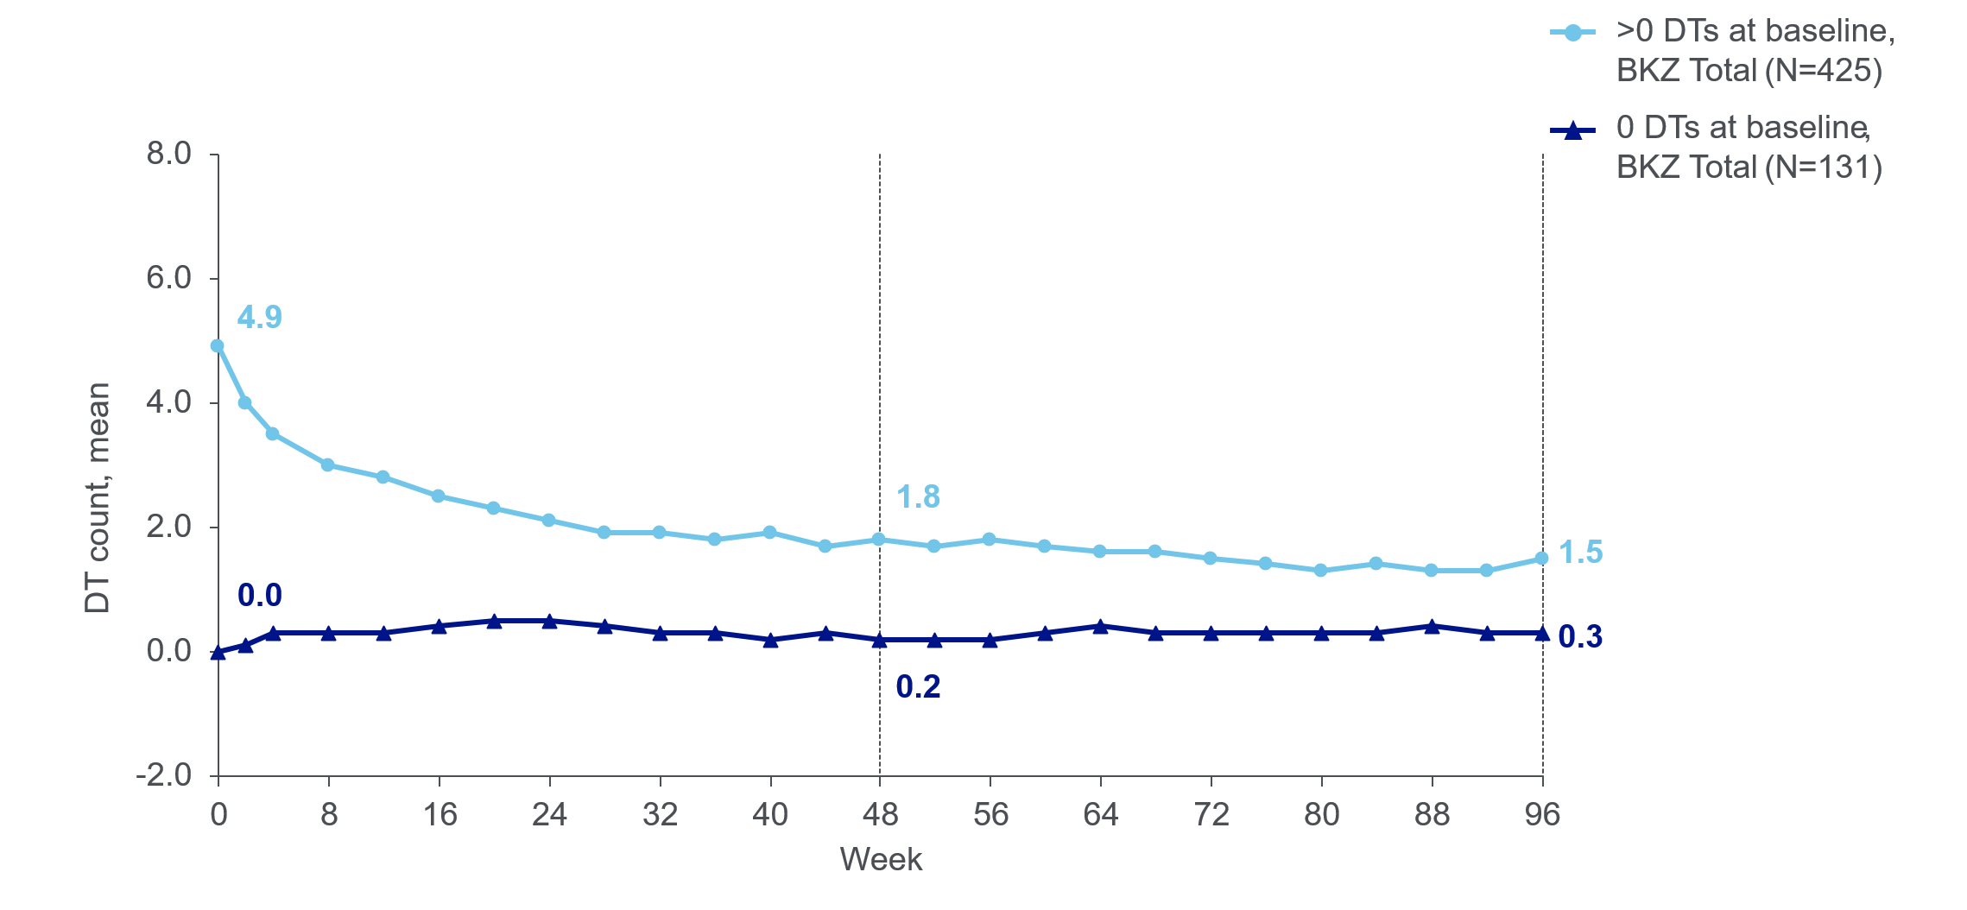
Mean DT count over time (MI [AE-LoE])ª

Mean absolute change from baseline in DT over time (MI [AE-LoE])ª
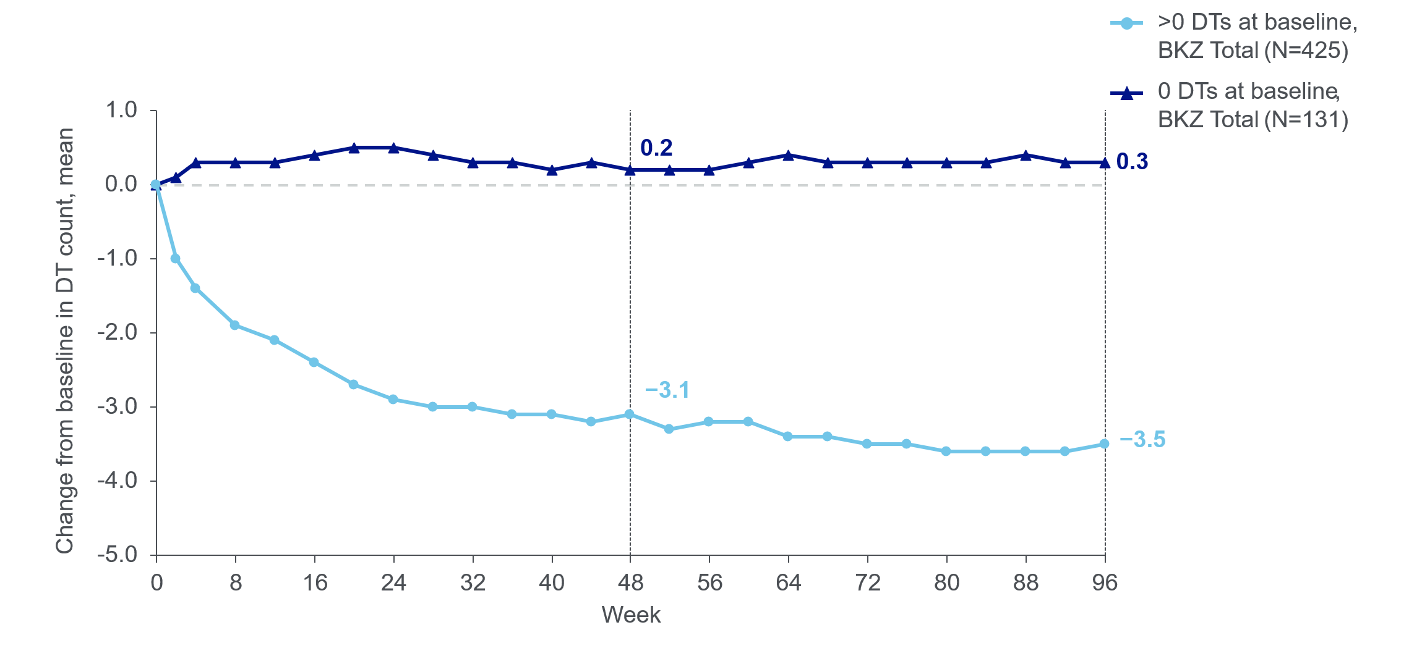

HSSQ skin pain response rates (mNRI [AE-LoE])^{b,c}
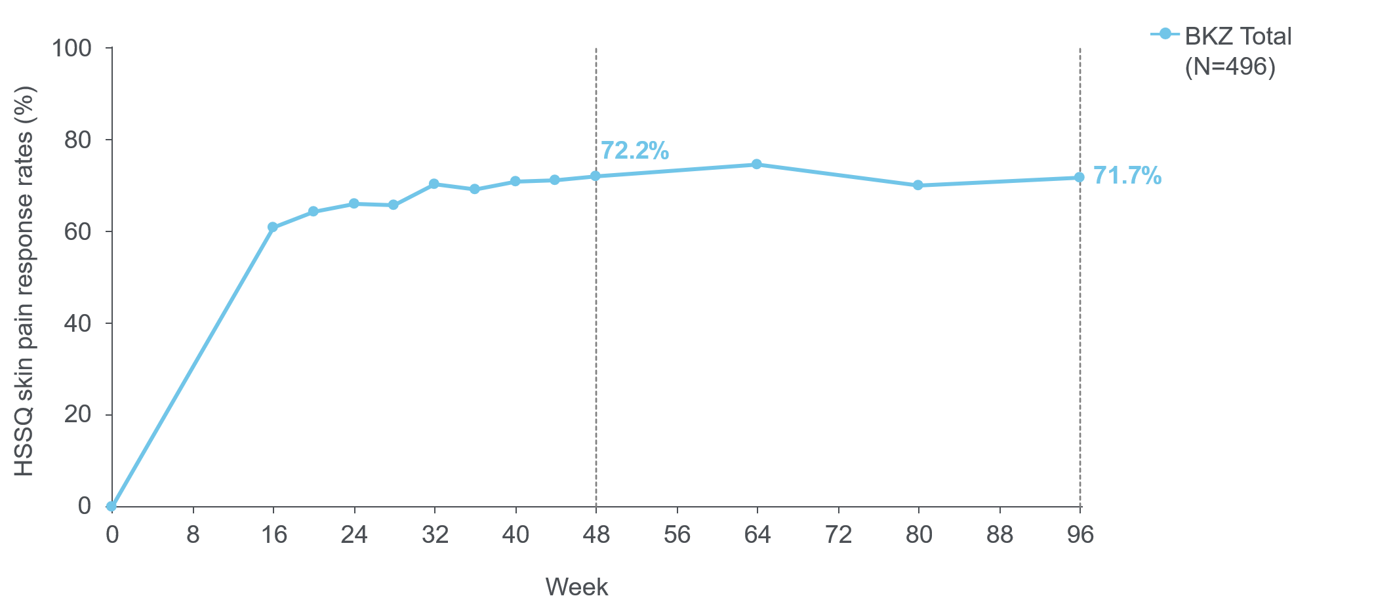

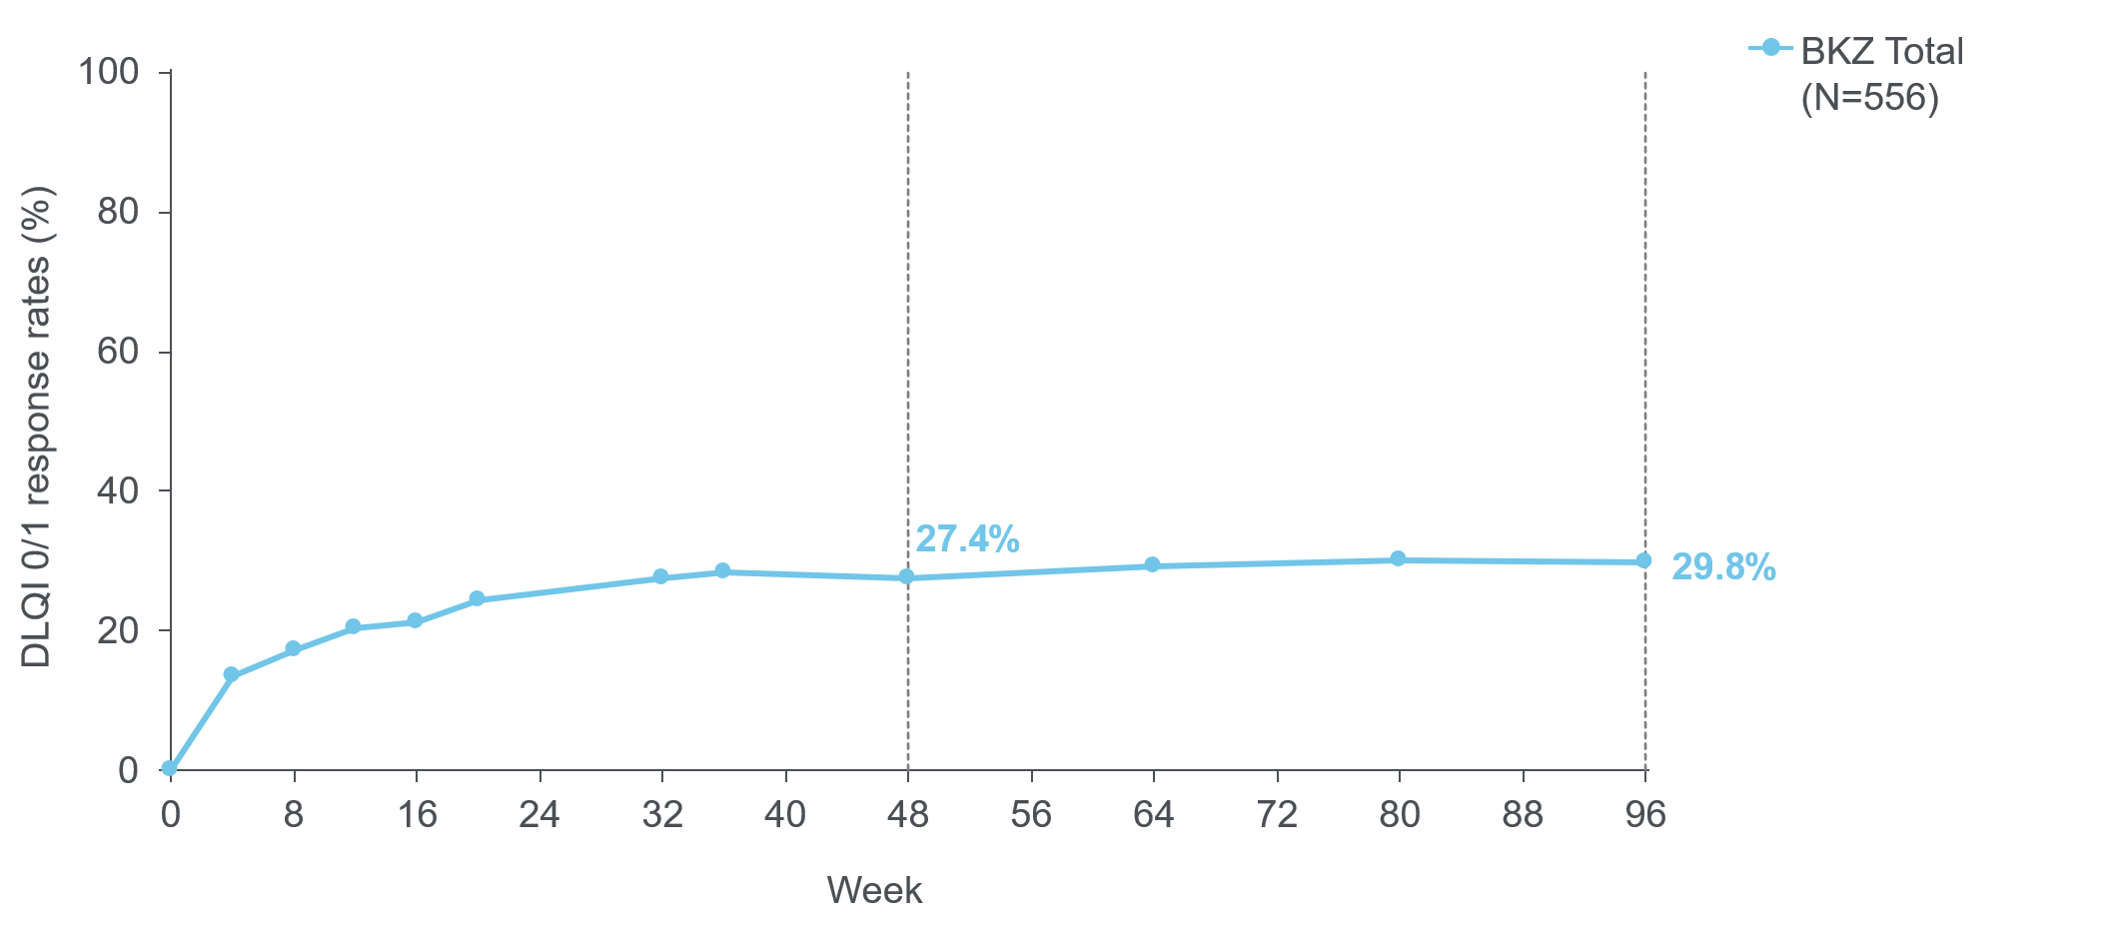
DLQI 0/1 Response Rates (mNRI [AE-LoE])^{b,d}
Hidradenitis suppurativa. OLE set: 657 BE HEARD I and II completers entered BE HEARD Extension at Week 48, of which 556 received BKZ from baseline (BKZ Total). Data for patients in BKZ Total are presented. For AE-LoE, discontinuation due to adverse event or lack of efficacy constitutes an intercurrent event. [a] Intermittent missing data were imputed using multiple imputation with MCMC method followed by monotone regression for monotone missing data. Patients who experienced an intercurrent event were treated as missing following the intercurrent event and imputed using the multiple imputation method for missing data. [b] Intermittent missing data were imputed using multiple imputation with MCMC method followed by monotone regression for monotone missing data. Lesion counts were imputed and then dichotomized to obtain the response status. Patients who experienced an intercurrent event were treated as non-responders following the intercurrent event.
[c] HSSQ response defined as at least a 30% reduction and ≥1 point reduction in HSSQ skin pain score, among patients with a baseline score of ≥3. [d] A DLQI response was defined as total scores of 0 or 1 (no impact of disease on HRQoL). AE-LoE: adverse event or lack of efficacy; AN: abscess and inflammatory nodule; BKZ: bimekizumab; DLQI: Dermatology Quality of Life Index; DT: draining tunnel;
HRQoL: health-related quality of life; HSSQ: Hidradenitis Suppurativa Symptom Questionnaire;
MCMC: Markov Chain Monte Carlo; MI: multiple imputation; mNRI: multiple non-responder imputation; OLE: open-label extension.

Supplementary Table 1. HiSCR50/75/90/100 over time in patients receiving BKZ Q2W/Q4W/Q4Wª (OC)
Week | HiSCR50  % (n/N) | HiSCR75  % (n/N) | HiSCR90  % (n/N) | HiSCR100  % (n/N)
2 | 33.8 (25/74) | 16.2 (12/74) | 8.1 (6/74) | 6.8 (5/74)
4 | 56.8 (42/74) | 28.4 (21/74) | 14.9 (11/74) | 10.8 (8/74)
8 | 70.8 (51/72) | 44.4 (32/72) | 34.7 (25/72) | 29.2 (21/72)
12 | 75.7 (56/74) | 55.4 (41/74) | 40.5 (30/74) | 31.1 (23/74)
16 | 87.8 (65/74) | 75.7 (56/74) | 45.9 (34/74) | 35.1 (26/74)
20 | 91.9 (68/74) | 73.0 (54/74) | 50.0 (37/74) | 36.5 (27/74)
24 | 88.0 (66/75) | 73.3 (55/75) | 56.0 (42/75) | 41.3 (31/75)
28 | 94.7 (71/75) | 90.7 (68/75) | 68.0 (51/75) | 52.0 (39/75)
32 | 91.8 (67/73) | 84.9 (62/73) | 72.6 (53/73) | 49.3 (36/73)
36 | 100 (74/74) | 98.6 (73/74) | 87.8 (65/74) | 58.1 (43/74)
40 | 100 (72/72) | 100 (72/72) | 91.7 (66/72) | 68.1 (49/72)
44 | 100 (73/73) | 100 (73/73) | 91.8 (67/73) | 78.1 (57/73)
48 | 98.7 (74/75) | 93.3 (70/75) | 81.3 (61/75) | 60.0 (45/75)
52 | 90.5 (67/74) | 83.8 (62/74) | 77.0 (57/74) | 64.9 (48/74)
56 | 93.2 (69/74) | 85.1 (63/74) | 67.6 (50/74) | 58.1 (43/74)
60 | 96.0 (72/75) | 82.7 (62/75) | 66.7 (50/75) | 56.0 (42/75)
64 | 93.2 (69/74) | 85.1 (63/74) | 75.7 (56/74) | 62.2 (46/74)
68 | 84.1 (58/69) | 82.6 (57/69) | 76.8 (53/69) | 62.3 (43/69)
72 | 85.9 (61/71) | 77.5 (55/71) | 70.4 (50/71) | 56.3 (40/71)
76 | 93.0 (66/71) | 83.1 (59/71) | 67.6 (48/71) | 59.2 (42/71)
80 | 92.9 (65/70) | 78.6 (55/70) | 68.6 (48/70) | 64.3 (45/70)
84 | 93.9 (62/66) | 87.9 (58/66) | 68.2 (45/66) | 60.6 (40/66)
88 | 89.6 (60/67) | 83.6 (56/67) | 71.6 (48/67) | 58.2 (39/67)
92 | 92.2 (59/64) | 85.9 (55/64) | 78.1 (50/64) | 73.4 (47/64)
96 | 90.8 (59/65) | 87.7 (57/65) | 76.9 (50/65) | 69.2 (45/65)

Hidradenitis suppurativa. OLE set: 657 BE HEARD I and II completers entered BE HEARD Extension at Week 48. [a] Data are reported for patients who were randomized to receive Q2W/Q4W in the initial/maintenance period and received Q4W on OLE entry. The denominator for n/N represents the number of patients with a non-missing lesion count assessment at the given week and percentages are calculated accordingly (i.e. where data recorded after an intercurrent event are included as recorded). BKZ: bimekizumab; HiSCR: hidradenitis suppurativa clinical response;
HiSCR50/75/90/100: ≥50/75/90/100% reduction from baseline in the total abscess and inflammatory nodule count with no increase from baseline in abscess or draining tunnel count; OC: observed case; OLE: open-label extension; Q2W: every 2 weeks; Q4W: every 4 weeks.

